Andrew Chen 04 01 2026
Report for EEG Lab
Follow the Colab file “HSI Lab 6 – EEG.ipynb” and record your process and results in this document.
* For each step, provide sufficient explanation of the process of reaching the final result or plot
* For each plot to report, include proper axis labels and units. For each numerical result to report, include proper units
- Research brain wave bands
What I did: Googled common frequencies for different brainwave bands.
Results: 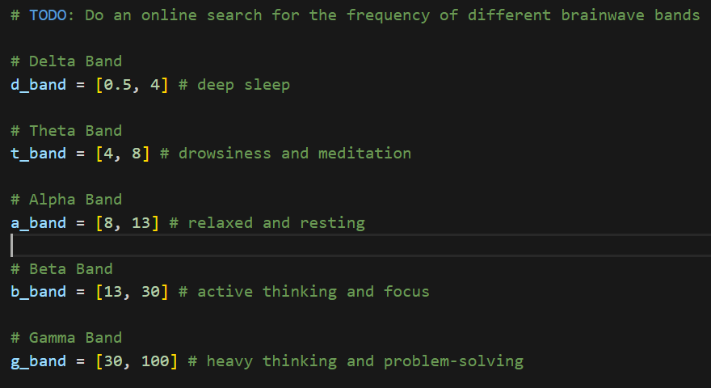

- Load Raw Data
What I did: Loaded data using input of 5 columns to parse data.
Plot: 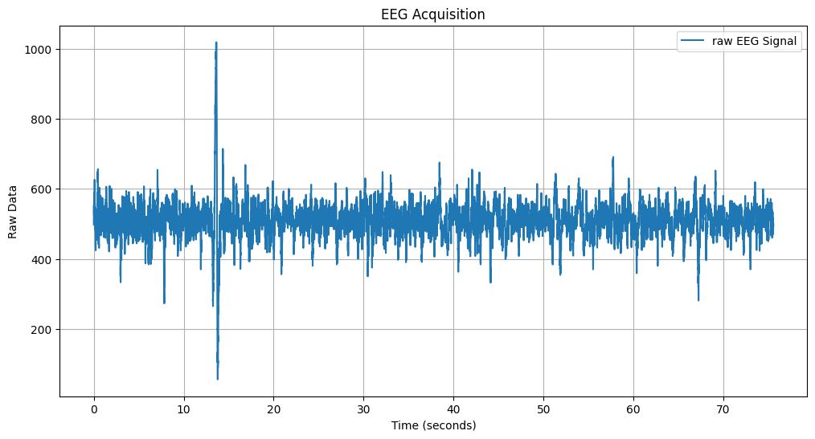

- Apply band-pass filter
What I did: [Please describe the parameter selection reasoning and/or tuning process] Applied a bandpass filter of 0.5 – 50, as this captures the majority of the brainwave bands I researched.
Plot: 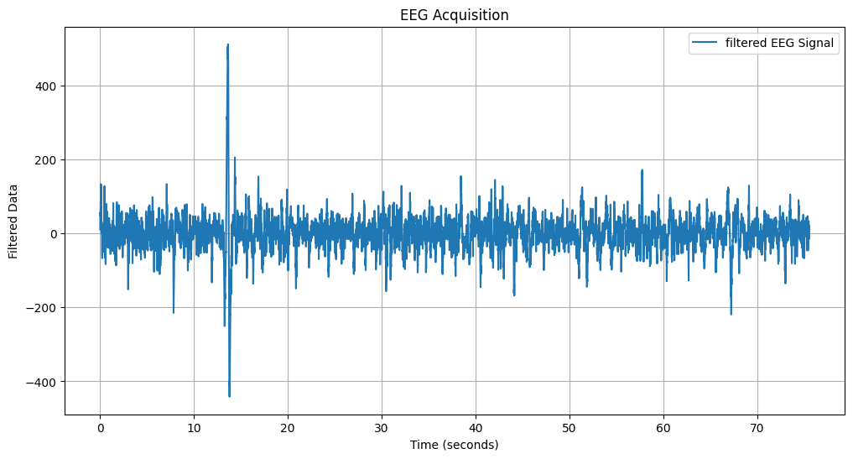

- Data segmentation
What I did: Split the data into 5 second chunks
Result: With a sampling frequency of 1000 Hz, each 5-second segment contained 5000 data points. For the resting dataset (EEG_ref.txt), this resulted in 14 to 15 total samples.

- PSD analysis
What I did: Used welch function to calculate the PSD. Used fs*2 as my nperseg as it was recommended in online literature.
Result: 2000

- Brain wave plot
What I did: Plotted the PSD of each brain wave for every collected sample
Plot: 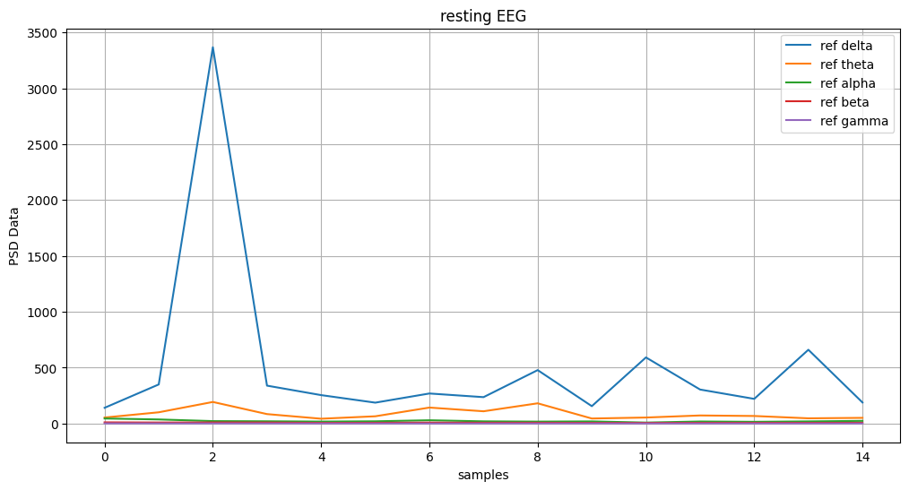
Discussion: The Delta band is significantly higher than all other bands. This is expected in forehead EEG because the sensor is placed directly above the eyes. The Alpha and Beta bands remain low and stable, which is consistent with a subject who is resting with their eyes open

- Alternative Scenario Processing
What I did: Applied the same process to the alternative dataset
Results: The dataset produced significantly more samples (~60) than the resting set (~15). The PSD for the different brainwave bands was also different. Although the trends were different, the delta band also dominated in this dataset.
Plot: 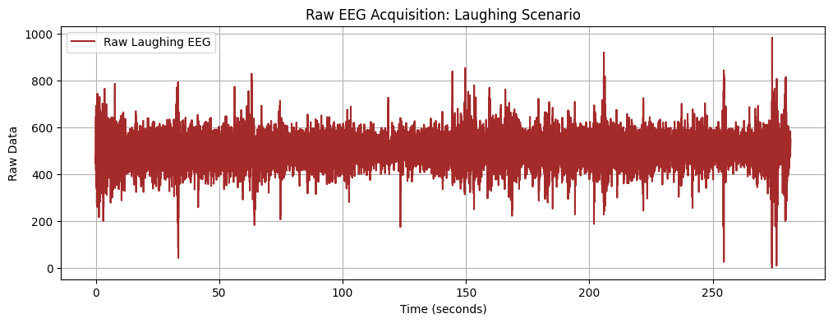 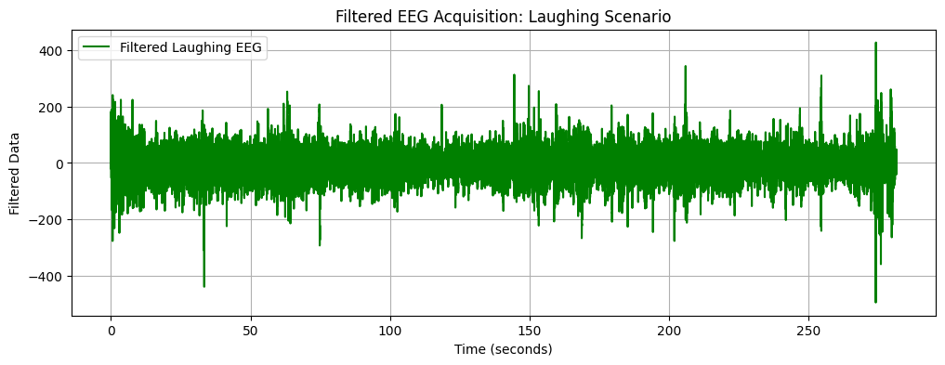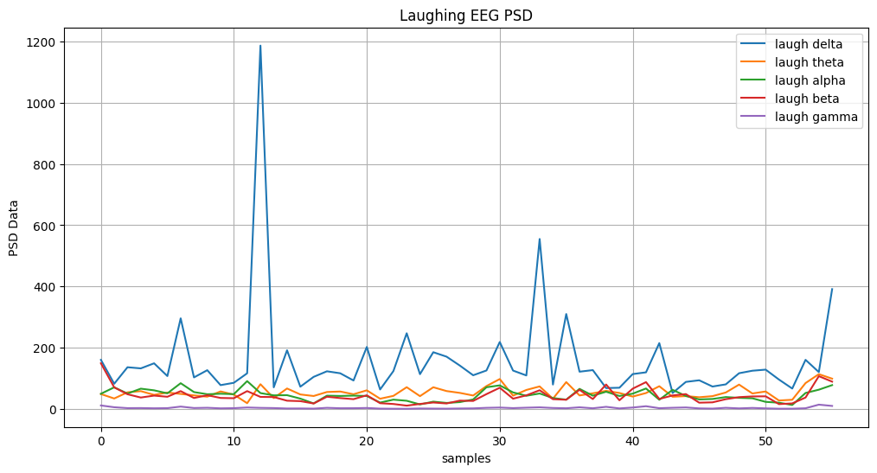
Discussion: The results show a significant increase in signal volatility. While most of the bands are low and quiet, the delta band was sporadic across the samples, jumping and spiking throughout. This is likely because laughing sends signals throughout the brain and also causes facial muscles to activate. These physiological artifacts have much higher electrical power than actual brain waves, causing the observed spikes in the PSD across all frequency bands.

- Comparison of two scenarios
Plot:
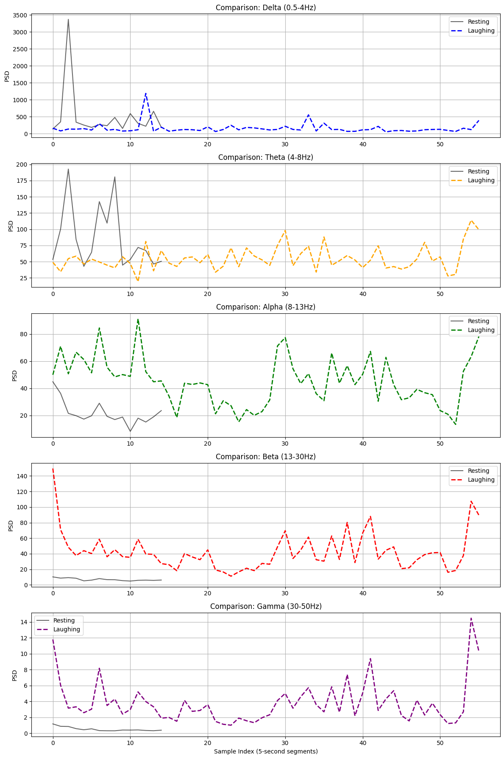
Discussion: The comparison shows that laughing creates massive muscle (EMG) and eye (EOG) noise that drowns out actual brain signals on a forehead EEG. While the Resting state is quiet and stable with only occasional blink spikes, the Laughing state is extremely volatile with high-power spikes across all bands, especially in Beta and Gamma. This proves the sensor is picking up facial expressions rather than just neural activity.

- Link to Colab file: https://drive.google.com/file/d/1Ni7Ip-twIJyGuaENVNPcFUcZKjxXiB6W/view?usp=sharing

